AI Index Search in Databricks:

End-to-end index build
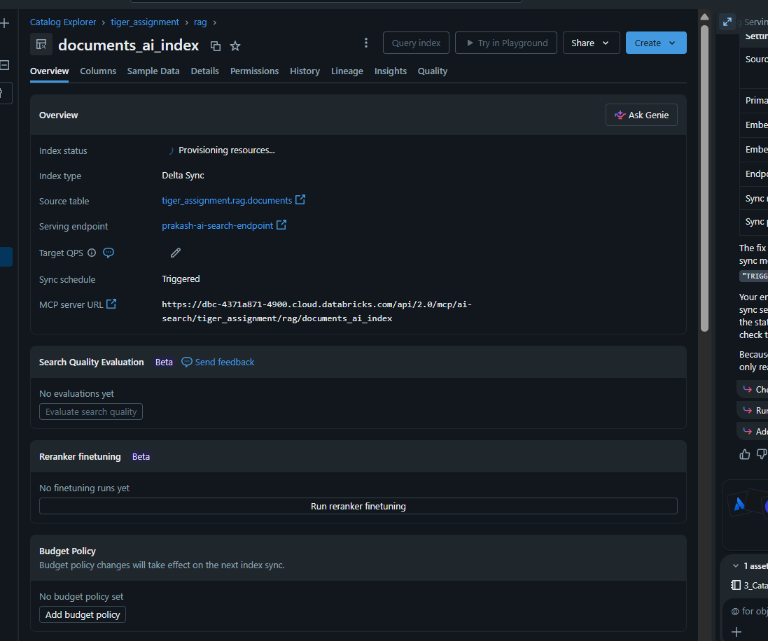

from databricks.vector_search.client import VectorSearchClient

client = VectorSearchClient()

index = client.get_index(
endpoint_name="prakash-ai-search-index-v2",
index_name="tiger_assignment.rag.documents_ai_index_v2"
)

results = index.similarity_search(
query_text="customer revenue",
columns=["id", "document_name", "content"],
num_results=3
)

print(results)

just now (1s)
10:
End-to-end index build
[NOTICE] Using a notebook authentication token. Recommended for development only. For improved performance, please use Service Principal based authentication. To disable this message, pass disable_notice=True. [NOTICE] Using a notebook authentication token. Recommended for development only. For improved performance, please use Service Principal based authentication. To disable this message, pass disable_notice=True. {'manifest': {'column_count': 4, 'columns': [{'name': 'id'}, {'name': 'document_name'}, {'name': 'content'}, {'name': 'score'}]}, 'result': {'row_count': 3, 'data_array': [['1', 'Customer_Sales_DRD.docx', 'Customer sales report contains revenue, customer id, fiscal year and sales metrics.', 0.5208639], ['2', 'Promotion_DRD.docx', 'Promotion records contain promotion id, start date, end date and discount amount.', 0.4023757], ['3', 'Inventory_DRD.docx', 'Inventory records track product stock quantity and warehouse location.', 0.39197809]]}}

Freshness test

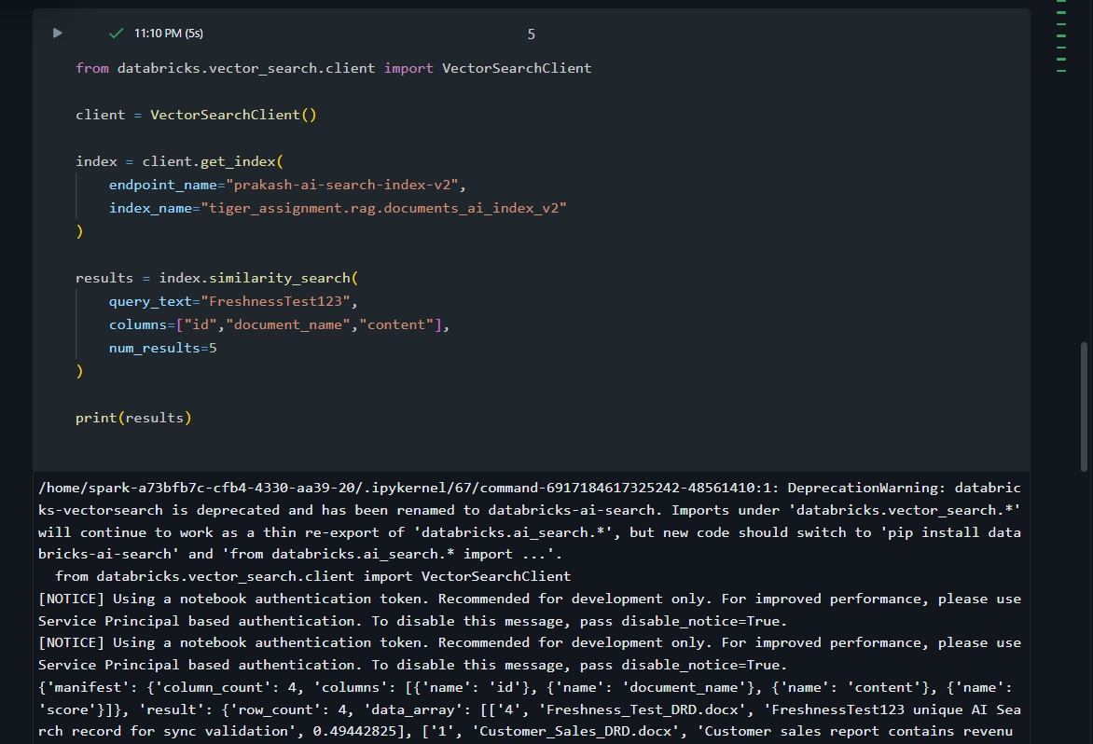

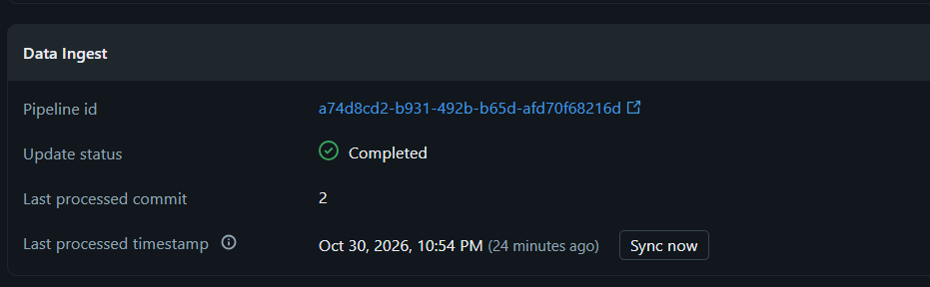

Process:

Insert Row
↓
Sync Now
↓
Index Updated
↓
Row Searchable

Filtered search
id | document_name | category | content
1 | Customer_Sales_DRD.docx | Sales | Customer sales report contains revenue, customer id, fiscal year and sales metrics.
2 | Promotion_DRD.docx | Promotion | Promotion records contain promotion id, start date, end date and discount amount.
3 | Inventory_DRD.docx | Inventory | Inventory records track product stock quantity and warehouse location.
4 | Freshness_Test_DRD.docx | Testing | FreshnessTest123 unique AI Search record for sync validation

Filter : Category = ‘Sales’
results = index.similarity_search(
query_text="report information",
columns=["id", "document_name", "category", "content"],
filters={"category": "Sales"},
num_results=5
)

print(results)

{'manifest': {'column_count': 5, 'columns': [{'name': 'id'}, {'name': 'document_name'}, {'name': 'category'}, {'name': 'content'}, {'name': 'score'}]}, 'result': {'row_count': 1, 'data_array': [['1', 'Customer_Sales_DRD.docx', 'Sales', 'Customer sales report contains revenue, customer id, fiscal year and sales metrics.', 0.44145003]]}}

A metadata-based filtered search was implemented using the category column. First, a semantic similarity search was executed without filters, returning documents from multiple categories. The same query was then executed with a metadata filter (category='Sales'). The filtered search returned only Sales-related documents while maintaining semantic relevance. This demonstrates the ability to combine vector similarity with metadata filtering to improve retrieval precision

Index type comparison

vsc.create_direct_access_index(
endpoint_name="prakash-ai-search-index-v2",
index_name="tiger_assignment.rag.documents_direct_index",
primary_key="id",
embedding_dimension=1024,
embedding_vector_column="embedding",
schema={
"id": "string",
"document_name": "string",
"content": "string",
"embedding": "array<float>"
}
)

<databricks.ai_search.index.AISearchIndex at 0x7fc11c9f6930>

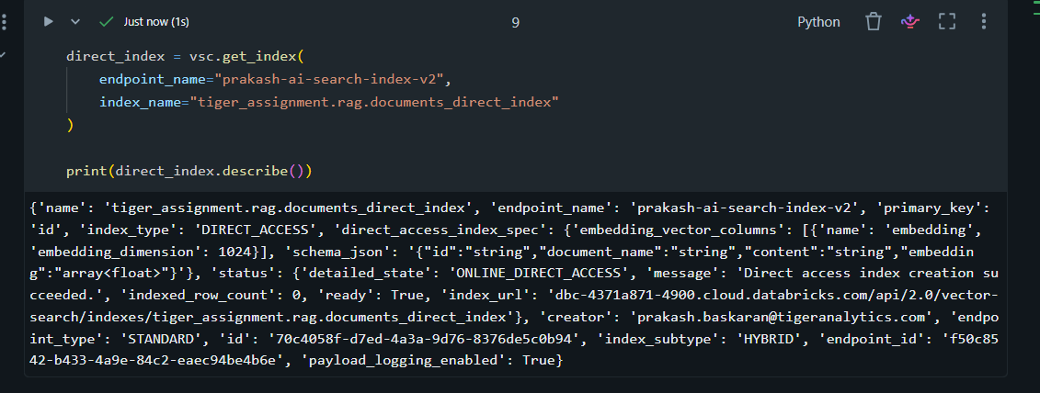
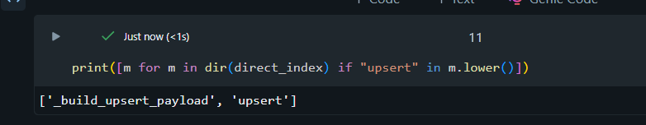

Query tuning


